This syllabus is subject to change at the discretion of the instructor.

Students will be notified and are responsible for any changes that are announced in class or via the class web site. Changes to the syllabus are posted in red!

MIS 360 Systems Analysis and Design

Instructor: Dr. Grant Meeting time: Tuesday 6 – 9:15 pm

Office Hours: Before class or by Appointment.

Office: DPC 6023 Phone: 312 362-6635 email: dgrant2@depaul.edu

Website: http://fac.comtech.depaul.edu/dgrant2/ Fax: 312 362 6208

Student Responsibilities
Students are expected to be prepared for class.
Students are expected to be on time for class.
Students are expected to attend all class sessions and stay for the duration of class.
Students are responsible for delivering assignments on time.
Students are responsible for doing their fair share of work on group projects.
Students are responsible for familiarizing themselves with the syllabus.
Students are responsible for and staying abreast with any subsequent changes to the syllabus.
Students are responsible for printing and carrying a copy of the syllabus.
Students are responsible for providing pencil and eraser on exams or quizzes.
Students are responsible for coming to class prepared.
Students are responsible for signing the attendance sheet.
Students should read the notes pertaining to the HW before attempting it.
Students should do practice problems before attempting the HW.
Students are responsible for knowing how to use Microsoft Visio. See file on how to use it
Students are responsible for any announcements made in class.

Course and Behavioral Objectives:
1. Students should be proficient in the use of techniques, methods, and tools for analyzing and designing information systems.
2. Students should understanding the fundamental concepts of Systems Analysis and Design
2. Students should be able to analyze and design information systems using UML.
3. Students should be familiar with issues and problems encountered by systems analysts.

Required Text:

Systems Analysis and Design: An Object Oriented approach with UML, 5th Ed, by Dennis, Wixom, and Tegarden, Publ. Wiley, ISBN 978-1-118-80467-4

Supplemental Readings:

Business Processes and Information Technology by Galinas, Sutton and Fedorowicz, Publ. Thompson Learning (3 chaps available on class website)

Chapter 12 Purchase to Pay (PtoP)

Questions to focus on:

Know the definitions of terms like, requisition, purchase order, accts receivables, accts payables, vendor packing slip, vendor invoice, and so on.

What are the primary functions of the PtoP process

What is the primary responsibility of the following depts. (accts payable, receiving dept, purchasing dept, inventory and so on) and the role that each manager of the dept plays?

What are the horizontal info flows that make the process function properly (p. 425-425) and why are they needed?

What are some of the sources of data used in the process and what is the importance of each data source. Try to identify as many data sources (data files).

Also read p 438-439.

Browse p 431-437.

Chapter 10 Order to Cash, Part I

Chapter 11 Order to Cash, Part II

Chapter 10 read Pg. 328-331;

Chapter 11 Billing Process read p. 387-388; read p. 375- 377

Know the definitions of terms like, bill of lading, packing slip, picking ticket, and so on.

What are the primary functions of the Order to Cash process

Repeat questions 3-5 above

Visio: the official guide, Visio Dummy Series, Visio Step-by-Step. This text is not required but is recommended. Employers expect MIS professional to be able to use Visio, a commonly used computer aided software engineering (CASE) tool.

Students Class-room Expectations

Students enrolled in ACC or MIS courses are expected to follow the highest level of professional ethics in all of their dealings. Outlined are a set of academic expectations:

1. Students are expected to take significant responsibility for learning, class preparation, delivery of timely assignments, and quality of work.

2. Students are expected to attend class, be punctual, stay for the entire class period, and take breaks only as designated by the professor. Students may get permission in advance from their professor for being late, absent, or leaving early (due to specified circumstances). Students are expected to refrain from disruptive activity during class. For example, cell phones are to be turned off, and student discussions should be conducted only as designated by the professor (typically, for classroom discussions, only one person should be talking at a time).

3. It is considered unethical for a student to seek to influence a grading decision by sharing information with the professor that is outside the stated grading criterion. For example, it would be unethical to notify a professor that a student needs a specific grade or a higher grade for reasons related to employment, reimbursement, or qualification for a scholarship.

4. Students are expected to become conversant with the DePaul University Academic Integrity Policy. That policy is included in the DePaul University Code of Student Responsibility. Students can find the Academic Integrity Policy at:

http://academicintegrity.depaul.edu/

5. Students are expected to represent themselves honestly in all communications, including all aspects of the job search process and scholarship applications.

Based on School of Accountancy & MIS Faculty Discussion in Fall 2012, examples of student classroom behaviors were discussed. Here are examples of classroom behaviors that were cited by faculty as being inappropriate:

- Talking in class when others are speaking
- Sleeping during class
- Excessive focus on grades instead of learning
- Use of laptops/ipads for non-classroom activities
- Cell phones ringing/sound not turned off
- Texting/emailing during class
- Arriving late to class/leaving early from class (unless excused, as per #2 above)
- Missing class and expecting faculty to replicate class material for individual student
- Students taking vacations during regularly scheduled dates of the quarter
- Bargaining/pleading for grades (in order to graduate or get employer reimbursement)
- Expecting curves on exams
- Expecting to told exactly what to study for an exam (just tell me what I need to know for the exam)
- Taking bathroom breaks during exams
- Low motivation for learning when nearing graduation

Grading Policy:

Grades will be rounded two one decimal place. Therefore, 92.95 will become 93. 0 = A while 92.94 will become 92.9 = A-.

Grades will be posted in D2L and final course grade will be determined by:

1. Exam 45% (70 MC questions, Activity and Use-Case diag); 100 pts

2. Assignments 25%

3. Project 30%

Score | Grade | Score | Grade | Score | Grade
93 | A | 80 | B- | 66 | D+
90 | A- | 77 | C+ | 60 | D
87 | B+ | 73 | C | < 60 | F
83 | B | 70 | C-

Quality of work:
Getting an excellent grade requires high quality work. This includes, but is not limited to the following:
- The use of paragraphs to express each main idea
- The use of a spellchecker
- No typos
- Clear expression and organization of ideas
- Supporting detail for main ideas
- Thoroughness and completeness of the assignment

Grading Expectations:
This course is challenging for several reasons. First, the course requires the modeling of several business processes and in order to model a process one must understand it. Therefore, it is extremely important that you read up on business process and talk to people who perform them. If you do not have a thorough understanding of a business process, you will do a poor job modeling it. It is not recommended trying to model a process if you do not understand how it works. Second, UML is a language used to model business processes and like any language it has rules of syntax and semantics. Syntax is related to the symbols and how they are used to construct diagrams. Semantics have to do with the meaning that is conveyed to the user through the diagram. Therefore, for each assignment your grade will depend heavily on several factors including syntax, semantics, thoroughness of the process, completeness of the process, aesthetics, and the extent to which good business policy is reflected. Third, most undergraduate students lack business process knowledge and so for the first time they are forced to think in business terms and model the business process at the same time. This is not an easy task for most students; hence research and an understanding of the business are required to do well.

Syntax: Points will be deducted for every syntax error.
Semantics: Points will be deducted for every instance where the meaning is ambiguous.
Thoroughness and completeness: points will be deducted if part of the business process is missing or incomplete.
Aesthetics: This is related to how the diagram looks to the user. If the diagram is not appealing and turns off the user thus causing him to lose interest, then points will be lost. Therefore, avoid crisscross lines.
Good business Policy: Good Business Policy should be reflected in the process if not points will be deducted. Good business policies involve business rules that would cause a business to thrive for a very long time and lend itself to high levels of customer satisfaction.

How I Grade HW and other Assignments (grading philosophy):
This section is intended to shed light on what to expect when I grade your work by incorporating more objectives measures in the grading process. It is clearly an attempt to remove as much subjectivity from the process. Grading often involves a measure of subjectivity, and the level of subjectivity varies with the topic and/or subject matter. In analysis and design it is impossible to remove subjectivity entirely because there is no single right or wrong answer to a given business problem. Some parts of a solution are naturally subjective; evaluating the aesthetic beauty or the semantic meaning of a diagram will always be subjective. Any business problem always has a range of possible solutions, some of which are clearly superior. My job is to determine the correctness of your solution and that is where my subject opinion and expertise play an important and inevitable role in the grading process. There are some parts of the grading process that lend themselves to more objective measures. I recognize that trying to be more objective has some limitations but I also recognize that moving to more objective measures has some merits. My intention is to incorporate more objective measures into the grading process. However, no matter what approach I use there are inherent limitations, hence the approach taken here is definitely a compromise yet somewhat imperfect. The upside to adopting more objective measures is that students know ahead of time how they will be evaluated. When they receive their graded assignments it would be clearer how they were graded especially on specific aspects of their solution. For example, every diagramming error will cost you a 2-point deduction (see list below). The down side to this approach is that some errors are more severe than others and I would have liked to reflect that in my grading. With this new approach that level of subjectivity is now removed by treating all errors as though they are equal. In reality, some errors are catastrophic while others are just insignificant.
In my attempt to objectify the grading process the best I can, here is how you will be evaluated. On a 100 point scale, two points will be deducted for every syntax or semantic error identified. Therefore, if an error is repeated you will loose 2 points every time. Here is an incomplete list of errors:

- Crisscross lines that could be avoided
- Confusing situation
- Missing process, activity, use case, class, object, etc.
- Inappropriate or poor labeling
- Part of the diagram is missing when printed
- Missing titles on diagrams
- Instances of poor business policy reflected in the diagram. Therefore, it is very important to provide a list of assumptions with explanations when necessary
- If the homework consists of two diagrams and you hand in only one, you will be graded out of 50%
- Missing boundary
- Missing actors
- Actors misplaced; actors should always be on the outside of the diagram
- Syntax or semantic violations not listed above

NOTE: 50 points will be deducted for submitting the wrong diagram. For example, submitting an overview use case diagram when the HW called for a detailed use case diagram. Please note that all the rules outlined here will be strictly enforced.

To do well on HW assignments, pay attention to these things:
- Pay attention to the list of errors above
- Spend a considerable amount of time researching and understanding the process before you model it
- Pay strict attention to the syntax
- Make sure each symbol of the diagram is correctly used and applied
- Do not try to create the diagram in one attempt; allow time to reread and improve the diagram over several iterations
- Check for completeness of the diagram
- Follow directions
- Avoid crisscross lines when possible because they detract from the beauty of the diagram and create confusion for the user. As the amount of confusion increases the amount of semantics decreases. It is also possible to have no crisscross lines yet the diagram is confusing (low on semantics).

Exams
The homework assignments provide the primary means of keeping students informed of their progress during the quarter. Students should use these as a vehicle for judging their strengths and weaknesses. The exams are made-up of multiple choice questions, and problems similar to the HW. There will not be any exam review sessions. Instead, students are strongly encouraged to ask questions at the beginning or end of each class. Preparing for the exam is an ongoing process which encompasses doing the HW, doing extra problems from the book, going over the review questions, studying regularly, asking questions in class, preparing for each class, and so on.

It is NOT enough to just read the book. Studying for exams require three things:
- Reading the book for understanding
- Studying is much more involved and complex than reading the book. It involves making connections between different and related concepts throughout the book. Identifying real world examples of concepts discussed in the book. Reflecting on what you have read and learned. Documenting the steps or process used to solve a problem. Making your own notes that make sense to you. Identifying other examples that reinforce concepts from the book. To accomplish these things often require you to consult Google, or other good sources such as text books.
- Practicing, which involves solving problems from the review and problem section of each chapter?

The exam will consists of 60 multiple choice questions, and two problems (AD and UCD) similar to those in the book. The multiple choice questions will cover basic definitions and terms from the text and is worth 1 point each.

Make-up Examinations
Make-up examinations are not encouraged, and are given only at the discretion of the instructor. If you miss the exam, you should have a doctor’s note to get a make-up. If you have out of town arrangements on the day of the final, you should notify the instructor by the second day of class. The only other reason for missing the final must be an emergency.

Workload
Students are advised to do all assignments that provide the necessary practice to become familiar with the material. It is inconceivable for students to do well in the course without expending sufficient effort and time practicing. Students should plan on spending about 9 hrs per week outside of class. I strongly recommend that students working full-time should not take more than two classes and full-time students should not work more than 20 hrs. Students working full-time and going to school full-time is a recipe for disaster.

Home-Work Assignments
All outside-of-class assignments (HW, project, etc.) are due at the beginning of class. Assignments not handed in by the end of class are considered late and will not be accepted and a grade of ZERO will be awarded. However, in exigent and extremely rare circumstances, the instructor reserves the right to apply a reasonable standard. Students may use any means necessary to get assignments in on time. All assignments not delivered in person should be postmarked and time-stamped. All assignments must be done with the aid of the computer. All diagrams MUST be done using Visio and text documents in Word. NO hand written assignments will be accepted; they will be returned to the student and late penalties will apply. When sending assignments via email, make sure to copy yourself and check the incoming email to ensure that the attachment was send correctly. Forgetting to attach your file will not be considered an excuse for late projects or assignments as penalties (grade of zero) for being late will apply. All Microsoft access files MUST be sent as a zip folder/file, ignoring this instruction will result in your file not being received. If ignoring these instructions results in your HW or project being late you will receive a zero. All students are responsible for knowing how to create and send zip files/folders. Microsoft Visio should be installed in Lewis on the 14th floor (1420). Free versions of Visio are available to DePaul students.

Mac users that need Visio should navigate to the Virtual Lab website: https://vlab.depaul.edu.
Reefer to install instructions listed on the page. Windows users who need access to Visio can install it via the University’s Microsoft Imagine Premium subscription (see https://offices.depaul.edu/information-services/services/Software/Pages/Software-for-Personal-Computers.aspx for more information, specifically the “Microsoft Imagine Premium” table row). Visio is provided at no cost via this subscription, but it is only available for Windows, not Mac.

Downloading Visio:
Visit http://software.depaul.edu page under “Software for Personal Computer”, then proceed with the link as shown below.

Microsoft Azure Dev Tools for Teaching  Provides free tools, including Project, SQL Server, Visio, Visual Studio, a free upgrade to Windows 10, and Windows Server. Read more on Microsoft's website. | STEM  Students | Windows | For use by STEM Students only:  Microsoft Azure Dev Tools for Teaching  Please sign in with your "@mail.depaul.edu" account

Once you login to “Microsoft Azure Dev Tools for Teacher” with your @mail.depaul.edu account, you will be able to find the Visio software (please see screenshot below).
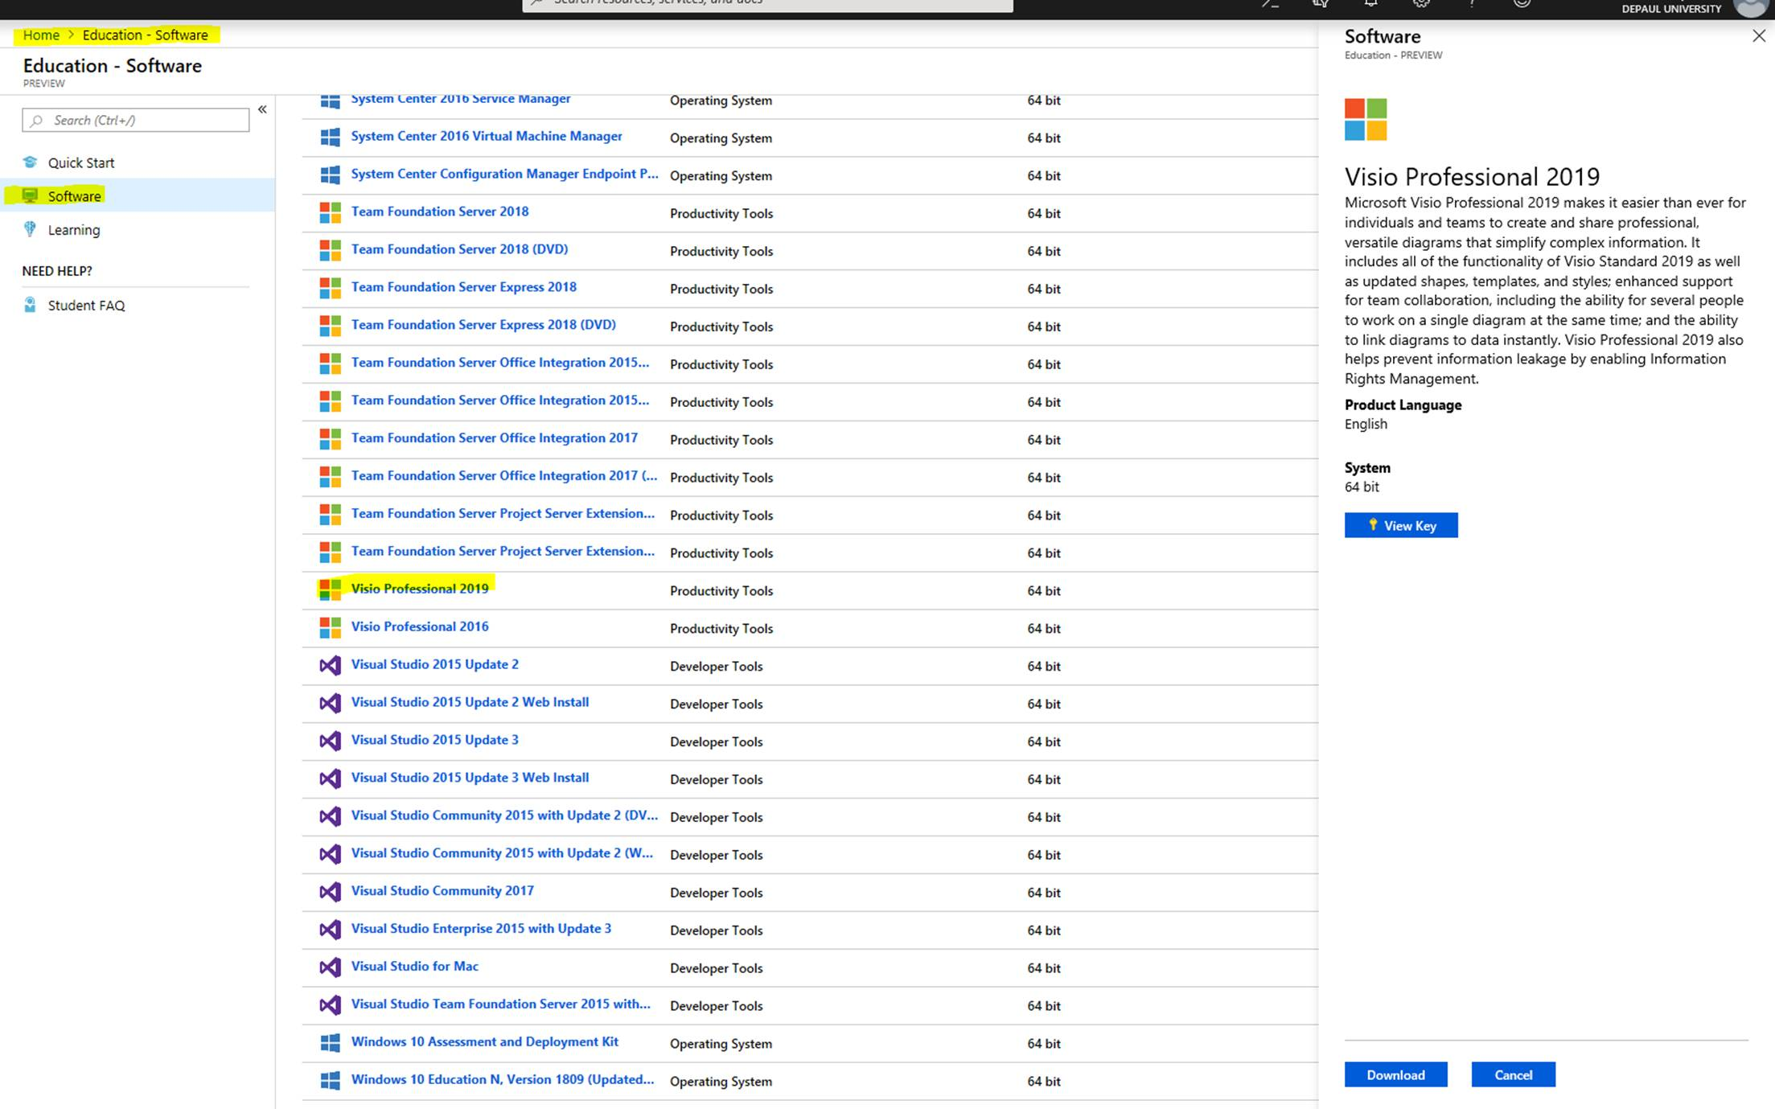

There are NO second chance on HW assignments so make sure to do your best on every assignment. Students are advised to do as many problems from the textbook or make up their own before attempting the homework. Learning how to model business requirements require lots of practice.

All homework assignments should include the name of the sender. This includes HW sent via email. It is not enough to have your name in the email; it must be on the HW.

Term Project
Team member information will be posted in D2L under the content tab.
The team project would be based on the Broadway Café which can be found on the class site. Each team will pick one of the five assigned topics in the project description.

Broadway Café Project Outline Draft
The project should include a cover page, table of contents with team member names attached, a short description of the business, and section headings. If there is any other item you would like to add feel free to do so.

Team members must decide how the work is to be divided equally among the team members. Who is responsible for the various parts of the project must be in the form of a written contract. A copy of the contract must be given to the instructor on the day the project outline is submitted. The contract must address penalties for team members who do not pull their weight. It must also address expectations of team members and each member must sign the document. Projects that do not have a contract will not be graded. Team members will evaluate their team mates at the end of the quarter. Print a copy of the peer evaluation form and turn it in to the instructor no later than the project due date. The total points for all team members, including you, MUST equal 100.

Project Requirements
These are some things that should be included in the project. Depending on the type of project some things may not be necessary, hence this is a guideline.
- Functional and nonfunctional requirements
- Activity diagram(s) that shows how the business functions
- Overview use case diagram(s)
- Windows navigation diagram (WND) showing the GUI layout
- The design of each GUI
- GUIs should correspond to the WND
- Narrative describing the business process
- Work break down structure showing the activities of the project
- Make sure to clearly label each diagram and each part of the report
- NOTE: the report must be double spaced and well written; points will be deducted for poorly written reports
- Project must have headings and subheadings
- Page numbers, table of contents identifying who worked on the various parts of the project
- Bibliography
- Deployment diagram
- Cover page
- Anything else that may be appropriate to your project

The GUI’s should correspond with the WND starting from top to bottom and left to right so that it is straight forward and easy for the reader to make the connection between GUIs and WND. The report must be computer generated and the diagrams must be done in Visio, VB, HTML, Visual Studio, or similar tool. The report must be neatly bound; no paper clips or loose pages will be accepted. To keep the project manageable, do not submit more than 20 GUIs. GUI’s should subscribe to the guidelines for good interface design and should include all the necessary information including buttons.

Anything that takes away from the clarity, readability, layout, organization, structure, and completeness of the report will be penalized. Here is a list of things that may cause you to loose points:

- not following instructions,
- poorly organized report,
- incomplete project,
- pages numbered incorrectly,
- missing table of contents or page numbers
- poor structure
- missing diagrams
- missing page numbers,
- diagrams and GUI’s missing labels,
- unrealistic and unreasonable business practices and assumptions
- criteria related to how HW will be graded,
- poor quality
- and so on.

Projects are due at the beginning of class. Therefore, if the project is incomplete submit what you have, even if you plan to ask for an extension. Under normal circumstances, each member receives the same grade as the team. However, students not pulling their weight can expect to receive a lower grade. This will be determined based on team member’s peer evaluation and the team contract agreement. For example, if I find that the work of a particular student was below average to the point that it affects the overall team grade, that student will receive a lower grade. What I am trying to prevent is students not pulling their weight and getting a free ride. So free riders beware; you are now warned!

It is strongly suggested that one student take on the responsibility of the team leader. Plan the project schedule, start the project early, leave enough time for unforeseen circumstances and report review. Make sure to create backup copies of the report. All correspondence should be documented in email and keep a record of all email. Email records could be used to settle disputes between team members. If agreements are made by phone still send email to confirm the details of the conversation.

It is strongly suggested that you research the business to get a good understanding of what is required and that reasonable and realistic business practices and assumptions are followed. Research may include talking to people, using the web, reading and so on. See me if you have unanswered questions.

Contract Agreement
The agreement should include all team members and their responsibilities. All parties must sign the contract. All parties must keep a copy of the signed contract. Copy of contract must be on file with the instructor. It is a good idea to specify how team members will be evaluated on the peer review form. Criteria may include attending meetings, being on time, delivering items as planned, returning emails and phone calls in a timely manner, quality of work, and so on.

Academic Misconduct
The DePaul Student Handbook states:
Violations of academic integrity include but are not limited to the following categories: cheating; plagiarism; fabrication; falsification or sabotage of research data; destruction or misuse of the university's academic resources-alteration or falsification of academic records; and academic misconduct. Conduct that is punishable under the Academic Integrity Policy could result in additional disciplinary actions by other university officials and possible civil or criminal prosecution. Full text located at http://condor.depaul.edu/~handbook/code17.html

Attendance
Students are encouraged to attend all class sessions on time. Students missing classes are responsible for what took place in class and are encouraged to get the class notes and other assignments from fellow students. Missing a class is not an excuse for being uninformed about class materials, assignments, due dates, and so on. Students are allowed to miss one class. Missing two or more classes will result in a 2% reduction per missed class from your final grade unless you have a doctor’s note. Example, miss three classes and 4% will be deducted from your final course grade. An attendance sheet will be circulated every class. It is the student’s responsibility to sign the sheet every class. Students who leave early or are absent when the attendance sheet is circulated, will be considered absent. Please see the student responsibility section.

NOTE: Excellent Resource for software videos:
There is a site called Lynda.com where you can find videos on various software including (SQL, Visio, Excel, etc). Type in lynda.com in your browser then select the login icon top right, then you will see the screen below. Use your DePaul acct to login using the option on the right by typing in www.depaul.edu follow the instructions to get to Lynda. Search for the software you want to learn.
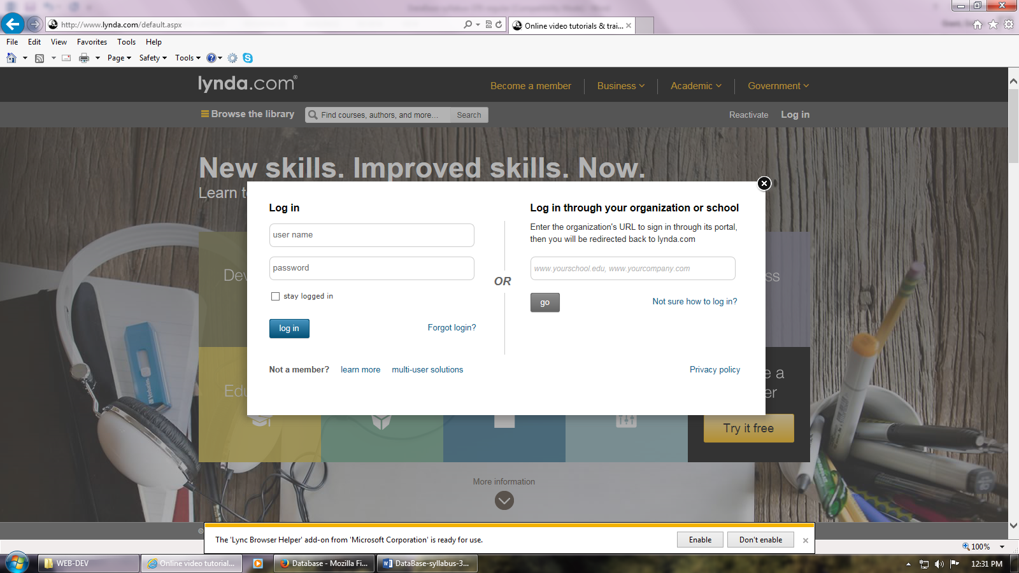

NOTES: To take quiz, log into D2L at 9:30 PM on the Day of the quiz.
UCD = Use Case Diagrams; AD = Activity Diagram

Date | Topic | Assignment Due
1/8 | Intro to Sys Analysis and Design | Chap 1
1/15 | Project Management  Requirements Analysis | Chap 2 (ignore pg 54 - end except for Timeboxing, and CASE Tools).  Chap 3 (ignore pgs. 95 to the end except for JAD, Concept Maps & User Stories)
1/22 | Functional Modeling (Activity Diag (AD)) | Chap 4
1/29 | Functional Modeling (Use case Diag (UCD))  Readings on Business Processes on website (see PDF link) | Chap 4 (AD Draft)  Business Processes in-class Skit  On-line quiz in D2L available from 9:00 pm today to 9 pm the following day.  Project Outline Draft & Proj Contract
2/5 | Structural Modeling | Chap 5 (UCD Draft)  HW: Activity Diag
2/12 | Behavioral Modeling | Chap 6
2/19 | Human Computer Interaction Layer  Physical Architecture Design | Chap 10  Chap 11  HW: Use Case Diag
2/26 | Teams work on project.  Lecture on Chap 12 & 13 is online;  See construction and installation video
3/4 | Teams work on project.
3/11 | Teams work on project. | Project due date: Friday before exam week. Not responsible for projects left outside the door.
3/18 | Exam covers (chap 1,2,3,4,5,6) activity and use case diags | Exam

Visio, and Project should be available in DPC Library, and O’Malley 1350.

Chap 4 Project mgmt.

Some topics in the chapter are deemphasized. Here are the sections that I concentrated on:
Project Identification – System Request
Feasibility Analysis
Timeboxing
Case Tools

I also expect you to know this material for the exam.

- What are the major challenges of project managers?
- What are the steps to create a work plan for a project?
- What is the easiest and simplest way to estimate a project, especially for inexperienced project managers?
- Project management requires project managers to make tradeoff, what are the tradeoffs?
- You should know what % of the project time is spent on planning. Knowing this industry standard, you should be able calculate the estimated time of the entire project.
- What is timeboxing, when and why do you use it?

THINGS YOU SHOULD KNOW AND REMEMBER

NOTE: This page may be updated from time to time.

The Text book is not perfect and so there are things in the book that I disagree with so I am letting you know what they are and what I expect of you in reference to all assignments and exams. When these things are missing from any assignment or exam (anything that is handed in or graded) you will lose points so it is important to have this list handy when doing assignments.

- All activities must have input and output therefore all object nodes must be shown. The one exception is related to decision activities. The activity diagram book example has a mistake. We will discuss these issues and how to deal with them. If I happen to forget it is your responsibility to remind me.
- Show all parts of a class (name, attributes, and methods).
- Show return messages on sequence diagrams
- Responsibilities of a class are the operations that the class can perform. It is not about the responsibilities of the actor. The book example is misleading so be aware of that. Remind me to discuss the book example.

